**A PROJECT REPORT**

On

**EMPLOYEE RECRUITMENT SYSTEM**

Submitted by

**SANCHIT GARG [11902873]**

**ABHISHEK SAINI [11902879]**

**PRANSHI PATEL [11902920]**

Under the supervision of

**Mr. Ishan Kumar**

At

Computer Science Engineering Department

(semester-3)



LOVELY PROFESSIONAL UNIVERSITY

JALANDHAR-DELHI, GRAND TRUNK RD. PHAGWARA, PUNJAB 144001

Submission Date: 2nd November , 2020

**ACKNOWLEDGEMENT**

I would like to thank my supervisor, Mr. Ishan Kumar for his guidance and comments on various aspects of this project and for thoughtful contribution

in my effort.

I am also thankful to lovely professional university for providing me an

opportunity to work in excellent working environment together with required resource.

And also my group member who helped me in this project also deserve

Thanks for their co-operation.

Last but not the least; I am very thankful to my friends for providing me

A valuable assistance during my work.

With pleasure

Abhishek Saini

Sanchit Garg

Pranshi Patel

**ABSTRACT**

This project Employee Recruitment system (ERS) is a system in which

Jobseekers can register themselves online, view organization requirement

and apply for the suitable job.

Employee recruitment system provides online help to the users all

Over the world. This kind of system play an important role in simplifying

The recruitment process.

The system has facilities where prospective candidate can upload their

CV’s and apply for jobs suit to them. It also makes it possible for organization

To post their staffing requirement and view profiles of interested candidates.

Earlier recruitment was done manually and it was all at a time consuming work.

Now it is all possible in a fraction of second. The system has been designed to

Do a whole lot more than just reduce paper work.

Employee recruitment system make possible for managers to access

information that is crucial to managing their staff, which they can use for human

Resource management, staffing and planning activities.

**LIST OF FIGURE**

|  |  |  |
| --- | --- | --- |
| **Figure** | **Title** | **Page no.** |
| 2.1 | Incremental Model | 9 |

**LIST OF TABLES**

|  |  |  |
| --- | --- | --- |
| **TABLE NO.** | **TITLE** | **PAGE NO.** |
| 2.1 | Project plan | 9 |
| 2.2 | Material and method | 8 |
| 2.3 | Role and responsibilities | 17 |

**INTRODUCTION**

**SUMMARY:**

Employee recruitment system by overall is aims to facilitate the applicant to

apply for the job online. Indirectly, it is also facilitate the managerial department

of an organization for an optimized and systematic employee recruitment process.

A quick look at the overall trend in online recruiting shows the rise in

the importance of recruiting on the web site, online training, dawn of video

interviews and emergence of professional internet recruiters.

Online recruitment systems, with its emphasis on a more strategic

decision making process is fast gaining ground as a popular outsourced function.

The system also provide the global platform for both – jobseekers and

the organization, where the jobseekers can find their dream jobs and organization

can find the right candidate to fulfill the staff requirements.

The system has web-forms like registration form, login form and

Account page like user applicant page, admin account page etc.

**PURPOSE:**

The primary purpose to develop this system is to optimize the recruitment

process for an organization. Besides, the qualified applicants could be sort

by this system based on their qualifications and company requirements.

**PROJECT SCOPE:**

Online recruitment system enables the users to have the typical recruitment

facilities and features at their disposal. It resolves typical issue of manual

staffing processes and activities into a controlled and closely monitored

workflow in the architecture of the application. The multiplatform solution

bring in my default, the basic intelligence and immense possibilities for

further extension of the application.

**OBJECTIVE:**

* The software helps applicants to find suitable job within the

organization and apply for that job easily.

* The software helps in managing the and viewing details of interested applicants for the administration.
* The system is capable of sorting and filtering bet suitable candidates

Based on some criteria.

* Company will not have to waste his time for finding right employee

At right place.

**MATERIAL AND METHOD:**

**MYSQL:** is the world’s second most widely used open-source relational

database management system (RDBMS). The SQL phrase stand

for structural query language. The MYSQL development project

has made its source code available under the terms of the GNU

general public license as well as under a variety of proprietary

agreements.

**GUI:** is a type of user interface through which users interact with

Electronic devices via visual indicator representations. GUI

Would become the standard of user-centered design in software

Application programming, providing users the capability to

Intuitively operate computers and other electronic devices through

the direct manipulation of graphical icons such as button, scroll bars

, windows tabs, menus etc.

**PROJECT PLANNING**

EMPLOYEE RECRUITMENT SYSTEM

Create account

UPDATE PROFILE DETAIL

VIEW VACANCY

login

CRITERIA

APPLY FOR JOB

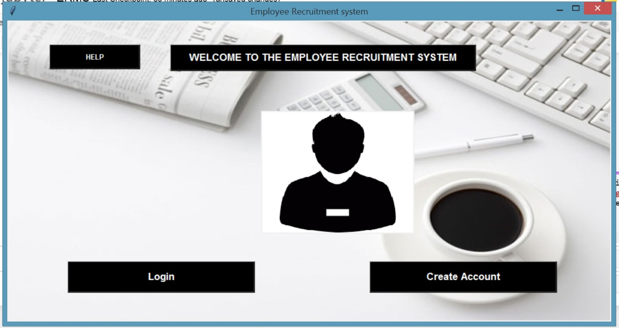

**STEP1:**

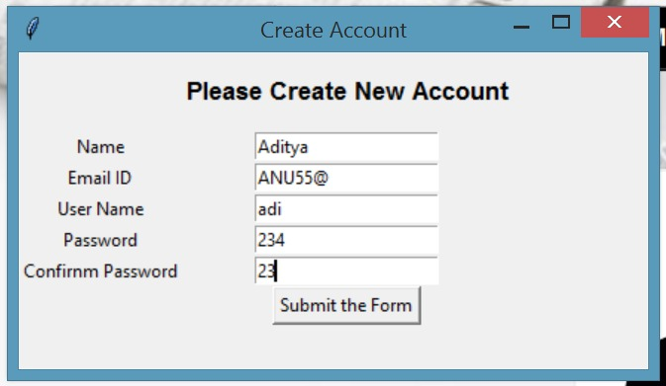

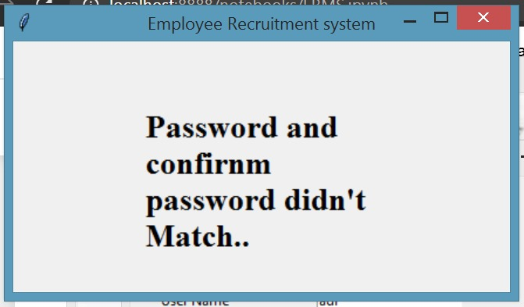

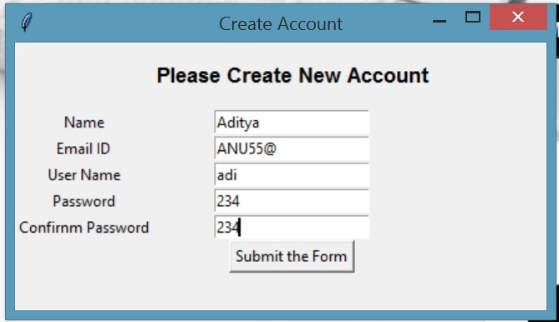

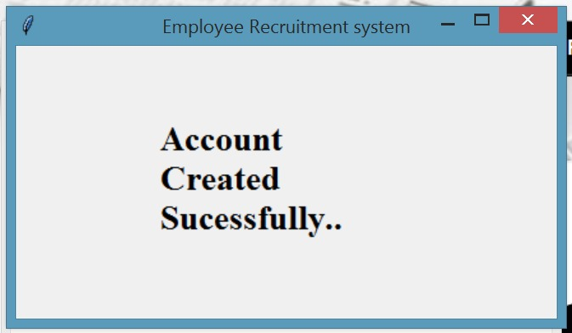

This password is stored in the data base and if user want to login then user can use this username and password for login.

* After creation of account

**STEP 2:**  first step is login Step in which applicant should login first then only he can apply or can update details.

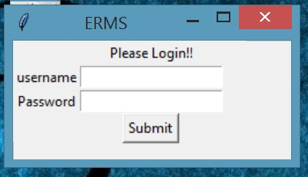

In case of wrong password, you get a message ‘access denied’.

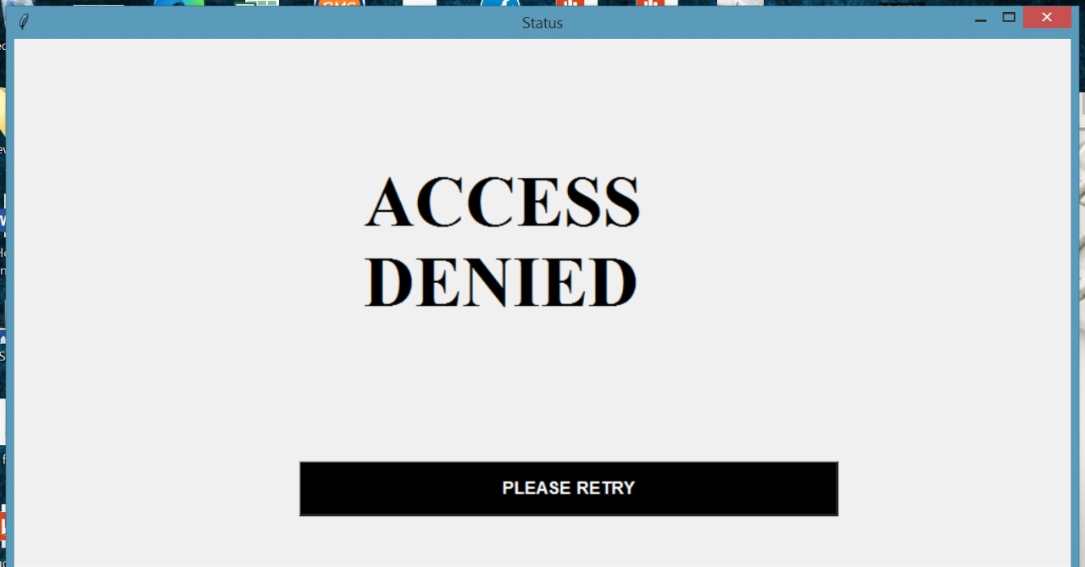

If password is correct then you can proceed to apply for job.

**STEP 3:** after login applicant can apply for job only when he or she fulfill

Criteria set by the company. Applicant also can view the vacancies

Of the company. In case password is wrong then employee is not able

to access the software.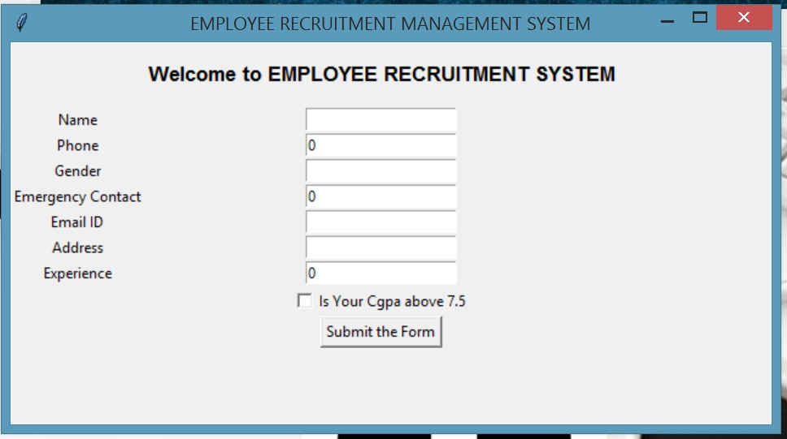

In this step you have to choose the CGPA that it is above 7.5 or below.

If below 7.5 then you get a output screen as “you can’t apply for this job”.

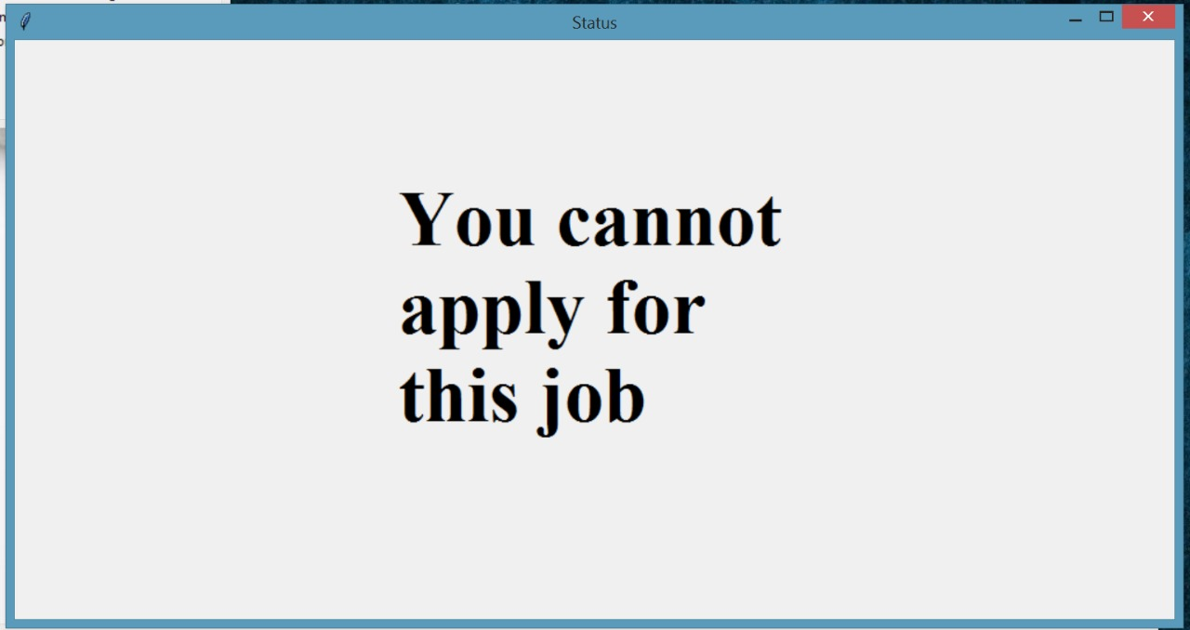

If your CGPA is more than 7.5 then you can apply and after filling the detail

You get a screen as.

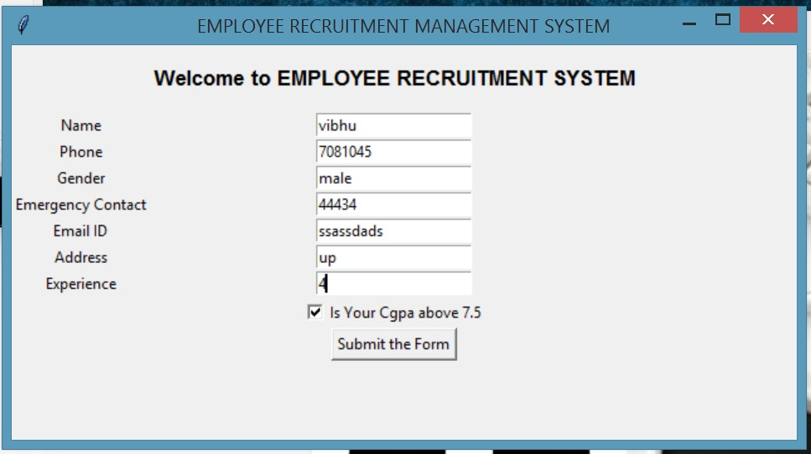

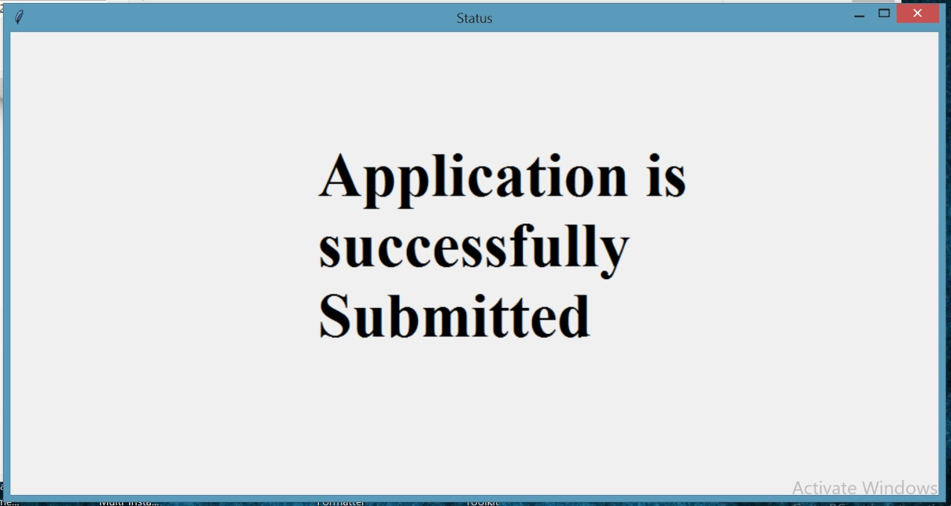

**STEP4:** If employee wants any help then there is help option.

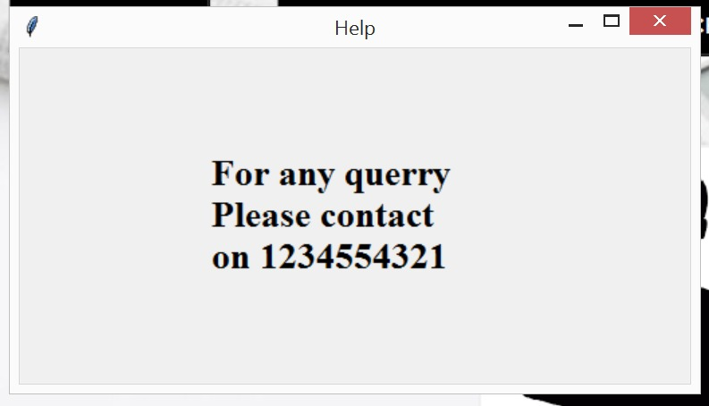

This is the plan of our project.

**PROJECT CONTRIBUTION:**

* **Project Report**

by

(Abhishek Saini)

* **Code**

by

(Sanchit Garg )

And

(Pranshi Patel)

**Review of literature:**

The main objective of this project is to make a direct connection between

Jobseeker and company. Earlier it was a manual process Which consume a

lots of time. In manual process data redundancy is a major problem.

It is a tough work to save a manual Records of thousand Employee.

Lots of worker needs to maintain a larger manual data and it increase

Financial problem of company.

**RESULTS:**

This project is solution of thousand problems like this project save time as

Well as money. Employee can upload their CV’S here and company can

Directly check your qualification and experience and according to that company can hire you.

* This is helpful to get a dream job for any jobseeker.
* Company can get a good and experienced employee for their work.

**APPENDICS:**

This project is applicable in the recruitment process.

**CONCLUSION:**

Recruitment as being one of the major topic is required by most of the

organization. Hence the study helped in understanding the various aspects

Of recruitment and selection process. The people who are searching for job they

Should you this to apply for job. To get a good job by online recruitment you

Have to work hard and collect extra knowledge so that no one can reject you

Application form. Jobseeker have to maintain their CV’S because it plays a major role in online recruitment process.